|  |  |
| --- | --- |
| **Total Marks:** | **7.5** |
| **Obtained Marks:** |  |

**DATA STRUCTURE**

**AND**

**ALGORITHM**

**Lab Report # 08**

**Submitted To: Mam Tehreen**

**_____________________________________________________________________________________________________________________________________________________________________________________________________________________________________**

**Submitted By**: **Hammad Qureshi**  .

**Reg. Numbers: 2112114**

**______________________________________________________________________________________________________________________________________________________________________________________________________________________________________**

**Question no 1:**

1. **Write a program which sort 10 number using bubble sort technique.**
2. **Write a program which sort 10 numbers using selection sort technique.**

**Code:**

|  |
| --- |
| **Part(a)**  #include<iostream>  using namespace std;    // A function to implement bubble sort  void bubbleSort(int arr[], int n)  {  int i, j;  for (i = 0; i < n - 1; i++)    // Last i elements are already  // in place  for (j = 0; j < n - i - 1; j++)  if (arr[j] > arr[j + 1])  swap(arr[j], arr[j + 1]);  }    // Function to print an array  void printArray(int arr[], int size)  {  int i;  for (i = 0; i < size; i++)  cout << arr[i] << " ";  cout << endl;  }    // Driver code  int main()  {  int arr[] = { 1, 9, 2, 8, 3, 7, 4, 6, 5, 0};  int N = sizeof(arr) / sizeof(arr[0]);  bubbleSort(arr, N);  cout << "Sorted array: \n";  printArray(arr, N);  return 0;  }  **Part(b)**  #include<iostream>  using namespace std;    //Swap function  void swap(int *xp, int *yp)  {  int temp = *xp;  *xp = *yp;  *yp = temp;  }    void selectionSort(int arr[], int n)  {  int i, j, min_idx;    // One by one move boundary of  // unsorted subarray  for (i = 0; i < n-1; i++)  {    // Find the minimum element in  // unsorted array  min_idx = i;  for (j = i+1; j < n; j++)  if (arr[j] < arr[min_idx])  min_idx = j;    // Swap the found minimum element  // with the first element  if(min_idx!=i)  swap(&arr[min_idx], &arr[i]);  }  }    //Function to print an array  void printArray(int arr[], int size)  {  int i;  for (i=0; i < size; i++)  cout << arr[i] << " ";  cout << endl;  }    // Driver program to test above functions  int main()  {  int arr[] = {10, 100, 90, 80, 70, 60, 50, 40, 30, 20};  int n = sizeof(arr)/sizeof(arr[0]);  selectionSort(arr, n);  cout << "Sorted array: \n";  printArray(arr, n);  return 0;  } |

**CONSOLE SCREEN:**

**Part(a)**

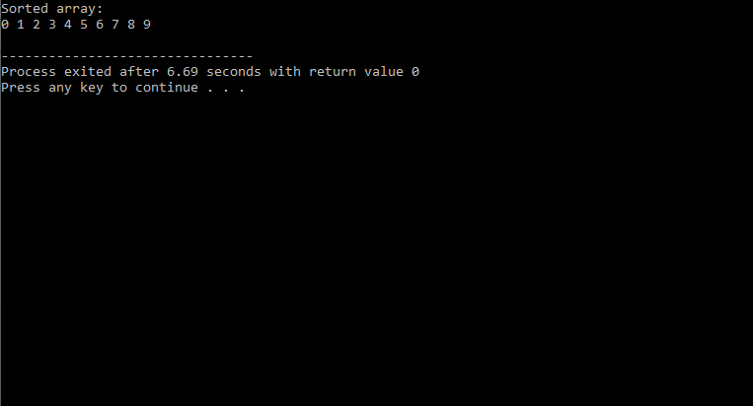

**Part(b)**

